**Assignment (Module 2)**

Que 1:- **what is software testing?**

Software testing is a process used to identify the correctness, completeness and quality of developed computer software.

Que 2**:- what is Exploratory Testing?**

Exploratory testing is a concurrent process where test design, execution and logging happen simultaneously. Testing is often not recorded.

Que 3**:- what is traceability matrix?**

To protect against changes you should be able to trace back from every system component to the original requirement that causes its present.

Que 4:- **what is boundary value testing?**

The boundary value analysis is a methodology for designing test cases that concentrates software testing effort on cases near the limit of valid ranges.

Que 5**:- what is equivalence partitioning testing?**

The numbers fall into a partition where each would have the same, or equivalent, result i.e. an equivalence partition or equivalence class.

Que 6**:- what is integration testing?**

Integration testing is a level of the software testing process where individual units are combined and tested as a group.

Que 7:- **what determines the level of risk?**

Que 8**:- what is alpha testing?**

Alpha testing is definitely performed and carried out at the developing organizations location with the involvement of developers.

* It is always performed by the developers at the softeware development site.
* It is not open to the market and public.
* It is always performed in virtual environment.
* It is the form of acceptance testing.
* It comes under both categories white box testing and black box testing.

Que 9:- **what is beta testing?**

Beta testing is performed and carried out by users or you can say people at their own locations and site using customer data.

* Beta testing is always performed at the time when software product and project are marketed.
* It is always performed by the customer at their own site.
* It is always open to the market and public.
* It is performed in real time environment.

Que 10:- **what is component testing?**

A minimal software item that can be tested in isolation. It means “ a unit is the smallest testable part of software.

Que 11:- **what is functional system testing ?**

A requirement that specifies a function that a system or system component must perform.

Ex. Accuracy, interoperability , compliance, auditability,

Que 12:- **what is non-functional testing?**

Testing of those requirements that do not relate to functionality.

Ex. Performance, load, data volumes, storage, recovery, stress, security.

Que 13**:- what is GUI Testing?**

GUI TESTING  is a software testing type that checks the Graphical User Interface of the Software. The purpose of Graphical User Interface (GUI) Testing is to ensure the functionalities of software application work as per specifications by checking screens and controls like menus, buttons, icons, etc.

Que 14**:- what is Adhoc testing?**

A adhoc testing is an informal testing type with an aim to break the system.

In fact is does not create test cases altogether.

Que 15:- **what is white box testing and list the white box testing?**

Testing based on an analysis of the internal structure of the component or system.

It is also known as structured based testing, white box, or glass box testing.

The different types of coverage are:

Statement coverage

Decision coverage.

Condition coverage.

Que 16:- **what is black box testing? What are the different black box testing techniques?**

Testing either functional or non functional without reference to the internal structure of the component or system.

It is also known as specification based testing technique.

There are four technique

* Equivalence partitioning
* Boundary value analysis.
* Decision tables
* State transition testing.

Que 17:- **mention what are the categories of defects?**

**Database, critical functionality, functionality, security, user interface.**

Que 18:- **mention what big bang testing is ?**

In big bang integration testing all components or modules is integrated simultaneously, after which everything is tested as a whole.

Big bang testing has a advantage that everything is finished before integration testing starts.

Que 19:- **what is purpose of exit criteria?**

* Successful testing of integrated Application.
* Executed test cases are documented.
* All high prioritized bugs fixed and closed.
* Technical document to be submitted followed by release Notes.

Que 20:- **when should “ Regression testing” be performed?**

when the system is stable and the system or the environment changes. When testing bug fix releases as part of the maintenance phase.

* Change in requirements and code is modified according to the requirement
* New feature is added to the software
* Defect fixing
* Performance issue fix.

Que 21**:- What is 7 key principles? Explain in details?**

1. Testing shows presence of Defects

* Testing can show that defects are present but cannot prove that there are no defects.
* Testing reduced the probability of undiscovered defects.
* The probability of undiscovered defects remaining in a system reduces.

1. Exhaustive testing is impossible.

* Testing everything including all combinations of inputs and preconditions is not possible.

1. Early testing

Testing activities should start as early as possible in the software or system development life cycle and should be focused on defined objective.

1. Defect clustering

A small number of modules contain most of the defects discovered during pre-release testing or are responsible for the most operational failures.

Defects are not evenly spread in a system they are clustered.

1. The pesticide paradox?

If the same tests are repeated over again and again, eventually the same set of test cases will no longer find any new defect.

To overcome this pesticide paradox the test cases need to be regularly reviewed and revised and different tests need to be written to exercise different parts of the software or system to potentially find more defects.

1. Testing is context dependent

Testing is done differently in different contexts

Different kinds of sites are tested differently.

1. Absence of error fallacy

If the system built is unusable and does not fulfil the user’s needs and expectations then finding and fixing defects does not help.

Que 22**:- difference between QA, QC and TESTER**

|  |  |  |
| --- | --- | --- |
| QA | QC | TESTER |
| It is a subset of software test life cycle. | It is a subset of QA | It is a subset of QC |
| Focus on processes and procedures rather than actual testing. | Focusing on actual testing | Focusing on actual testing |
| Process oriented activities. | Product oriented activities | Product oriented activities |
| Preventive activities | Corrective process | Preventive process |

Que 23:- **Different between smoke and sanity?**

|  |  |
| --- | --- |
| **SMOKE** | **SANITY** |
| * smoke testing is performed to ensure the critical functionality/ key features or the previous built. | Sanity testing is done to ensure the new functionality / bugs have been fixed. |
| * The objective of this testing is to verify the “ stability” of the system in order to proceed with more rigorous testing. | The objective of the testing is to verify the “ rationality” of the system in order to proceed with more rigorous testing. |
| * This testing is performed by the developers or testers. | Sanity testing is usually performed by testers only. |
| * This testing usually documented or scripted | This testing is usually not documented and its unscripted. |
| * Smoke testing is a subset of regression testing | Sanity testing is a subset of acceptance teting. |
| * Smoke testing exercises the entire system from end to end. | Sanity testing exercises only the particular component of the entire system. |
| * The smoke testing is like a General health check Up. | Sanity testing is like specialized health check up. |

Que 24. Different between verification and validation

|  |  |
| --- | --- |
| **VERIFICATION** | **VALIDATION** |
| * Before coding is called verification | after coding is called validation |
| * Verification done at the development level. | Validation done at the testing level. |
| * It brings static testing | It brings dynamic testing |
| * When verification start parallelly plan also start. | Validation we have to test by using the parallel plan. |
| * Are we building the product right? | Are we building the right product? |
| * Plans, requirement specs, design specs, code, test cases | testing |

Que 25. Explain types of performance testing.

**here are 5 main types of performance testing.**

* Capacity Testing.
* Load Testing.
* Volume Testing.
* Stress Testing.
* Soak Testing.

Que 26. What is error, defect, bug, failure?

ERROR:- A mistake in codding is called error.

DEFECT:- error found by tester is called defect.

BUG:- defect accepted by the development team.

FAILURE:- built does not meet the requirements then it is failure.

Que 27. Different between priority and severity?

SEVERITY:- severity is absolute and customer focused. It is the extent to which the defect can affect the software. Inn other words it defines the impact that a given defect has on the system.

PRIORITY:- priority is relative and business focused. Priority defines the order in which we should resolve a defect. Should we fix it now, or can wait? This priority status is set by the tester.

|  |  |  |
| --- | --- | --- |
| **Parameters** | **Severity in Testing** | **Priority in Testing** |
| Definition | Severity is a term that denotes how severely a defect can affect the functionality of the software. | Priority is a term that defines how fast we need to fix a defect. |
| Parameter | Severity is basically a parameter that denotes the total impact of a given defect on any software. | Priority is basically a parameter that decides the order in which we should fix the defects. |
| Relation | Severity relates to the standards of quality. | Priority relates to the scheduling of defects to resolve them in software. |
| Value | The value of severity is objective. | The value of priority is subjective. |
| Change of Value | The value of Severity changes continually from time to time. | The value of Priority changes from time to time. |
| Who Decides the Defect | The testing engineer basically decides a defect’s severity level. | The product manager basically decides a defect’s priority level. |
| Types | There are 5 types of Severities: Cosmetic, Minor, Moderate, Major, and Critical. | There are 3 types of Priorities:critical High, Medium, and Low. |

Que 28. What is bug life cycle?

**Defect Life Cycle** or Bug Life Cycle in software testing is the specific set of states that defect or bug goes through in its entire life. The purpose of Defect life cycle is to easily coordinate and communicate current status of defect which changes to various assignees and make the defect fixing process systematic and efficient.

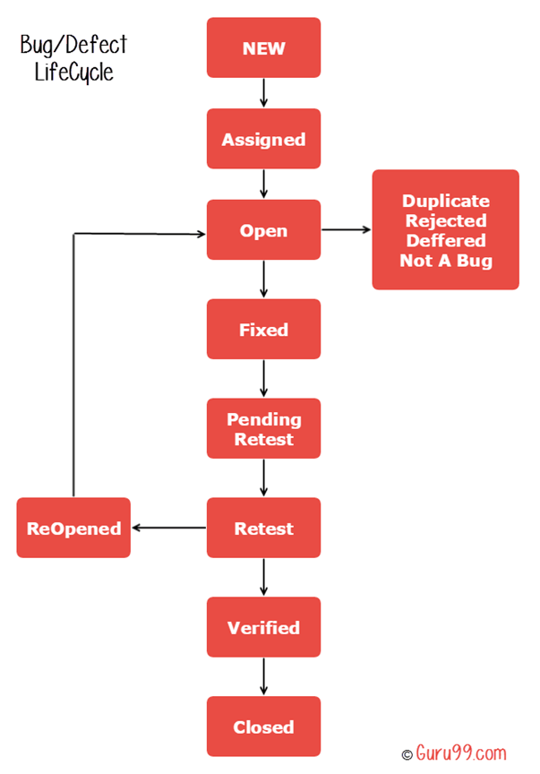

Que 29. Explain different between functional testing and non-functional testing.

|  |  |
| --- | --- |
| **FUNCTIONAL** | **NON-FUNCTIONAL** |
| It is performed using the functional specification provided. | It is check the performance reliability, scalability and other non- functional espects. |
| It is executed first. | It is executed after functional testing. |
| Manual and automation tools used for functional testing. | Using tools will be effective for this testing. |
| It is describes what product does. | It describes how good the product work. |
| Easy to do manual testing | Tough to do manual testing. |
| * Unit testing * Smoke testing * White box * Black box * User acceptance * Regressive | * Performance * Load * Volume * Tress * Security * Installation |

Que 30. What is the different between SDLC and STLC

|  |  |
| --- | --- |
| **SDLC** | **STLC** |
| * focusing on building a product. | * Focusing on testing a product. |
| * A parent process. | * It is a child of sdlc. |
| * Building a product as per requirements. | * Ensuring the product work as per expectation. |
| * SDLC phases completed before start testing. | * STLC phases start after SDLC phases completed. |
| * End goal is to deploy high quality product to user. | * End goal is to finding and fixing the bug/defect. |

**Que 31. What is the different between test scenarios, test cases and test script?**

|  |  |  |
| --- | --- | --- |
| Test scenario | Test cases | Test script |
| It is any functionality that can be tested. | It is set of actions executed to verify particular features or functionality. | It is a set of instructions that test app automatically. |
| It is derived from business specific requirements or software specific requirements. | It mostly derived from test scenario. | It mostly derived from test cases. |
| Helps test the end to end any functionality in agile way. | Helps in exhaustive testing of an app. | Helps to test specific thigs repeatedly. |
| Required less time and resources to create. | Required more time and resources to create. | Required less time but required more resources to creating. |
| Allowing quickly accessing the testing scope. | Allows detecting error and defect. | Allows carrying out an automatic execution of test cases. |

Que 32. Explain what Test Plan is? What is the information that should be covered.

Test plan is high level document in which how to perform testing is described. It is prepared by the test lead or manager and focus of the document is to describe what to test, how to test, when to test and who will do what test.

It covered like.

* Introduction to test plan documentation.
* Assumption when testing the application.
* List of the test cases
* List of the features of the testing.
* What approach to use while testing the software.
* List of deliverable that need to be tested.
* Any risk involved during the testing process.

Que 33. What are the different Methodologies in Agile Development Model?

The methodologies of agile development mode are SCRUM AND EXTREME PROGRAMING.

SCRUM:- “SCRUM is an agile development method which concentrates particularly on how to

manage tasks within a team based development environment. Basically, Scrum is derived

from activity that occurs during rugby match.”

It consists of three roles and their responsibilities are explained as follows:

▪ Scrum Master: Master is responsible for setting up the team, sprint meeting and

removes obstacles to progress

▪ Product owner: The Product Owner creates product backlog, prioritizes the backlog

and is responsible for the delivery of the functionality at each iteration

▪ Scrum Team: Team manages its own work and organizes the work to complete the

sprint or cycle

o Process Flow of Scrum

▪ Each iteration of a scrum is known as Sprint

▪ Product backlog is a list where all details are entered to get end product

▪ During each Sprint, top items of Product backlog are selected and turned into

Sprint backlog

▪ Team works on the defined sprint backlog

▪ Team checks for the daily work

▪ At the end of sprint, team delivers product functionality

⮚ extreme Programming

❖ This is a light weight agile testing methodology in which development and testing

happen in parallel. Business requirements are gathered in terms of stories.

❖ All those stories are stored in a place called parking lot.

❖ In this type of methodology, releases are based on the shorter cycles called

Iterations with span of 14 days’ time period.

❖ Each iteration include phases like coding, unit testing and system testing where

at each phase some minor or major functionality will be built in the application.

Que 34. Explain the difference between Authorization and Authentication in Web testing.

| **AUTHENTICATION** | **AUTHORIZATION** |
| --- | --- |
| * In the authentication process, the identity of users are checked for providing the access to the system. | While in authorization process, a the person’s or user’s authorities are checked for accessing the resources. |
| * In the authentication process, users or persons are verified. | While in this process, users or persons are validated. |
| * It is done before the authorization process. | While this process is done after the authentication process. |
| * It needs usually the user’s login details. | While it needs the user’s privilege or security levels. |
| * Authentication determines whether the person is user or not. | While it determines **What permission does the user have?** |
| * Generally, transmit information through an ID Token. | Generally, transmit information through an Access Token. |
| * The OpenID Connect (OIDC) protocol is an authentication protocol that is generally in charge of user authentication process. | The OAuth 2.0 protocol governs the overall system of user authorization process. |
| * Popular Authentication Techniques- * Password-Based Authentication * Passwordless Authentication * 2FA/MFA (Two-Factor Authentication / Multi-Factor Authentication) * Single sign-on (SSO) * Social authentication | Popular  Authorization Techniques-   * Role-Based Access Controls (RBAC) * SON web token (JWT) Authorization * SAML Authorization * OpenID Authorization * OAuth 2.0 Authorization |
|  |  |
| * The user authentication is visible at user end. | The user authorization is not visible at the user end. |
| * The user authentication is identified with username, password, face recognition, retina scan, fingerprints, etc. | The user authorization is carried out through the access rights to resources by using roles that have been pre-defined. |
| * **Example**: Employees in a company are required to authenticate through the network before accessing their company email. | **Example:** After an employee successfully authenticates, the system determines what information the employees are allowed to access |

Que 35. What are the common problems faced in Web testing?

**Below are five web application testing challenges faced by web developers during the development process.**

* Integration. Integration testing exposes problems with interfaces among different program components before deployment. ...
* Interoperability. ...
* Security. ...
* Performance. ...
* Usability. ...
* Quality Testing, Exceptional Services.